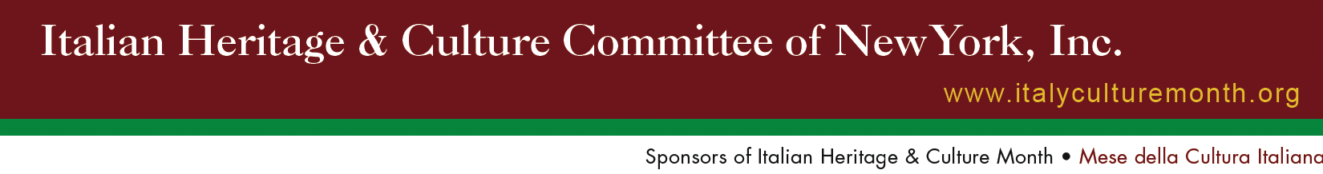
Founding Chairman
Gran. Uff. Angelo Gimondo, Ph.D.

Honorary Chairpersons
Honorable Francesco Maria Talò
Consul General of Italy
Dott. Renato Miracco
Director, Italian Cultural Institute of New York
Louis Tallarini
President, Columbus Citizens Foundation, Inc.
Cav. Joseph V. Scelsa, Ed.D.
President, Italian American Museum
Baronessa Mariuccia Zerilli-Marimò Trustee, New York University

Officers
President and Chairman
Cav. Uff. Joseph Sciame
Vice President
Claudia Massimo Berns
Treasurer
John Mustaro, P.E
Secretary
Mary Ann Re, Ph.D.

Committee Chairs
Co-Chair, Public Relations
Cav. Giuliana Ridolfi Cardillo
Nancy J. Indelicato
Chair, Marketing
John Battista De Santis
Chair, Membership
Maria C. Marinello, Esq.
Co-Chair, Special Projects
John Dabbene
Cav. Dott. Berardo Paradiso
Co-Chair, Programming
Cav. Joan Migliori
Anthony J. Tamburri, Ph.D.
Legal Advisor
Josephine Belli, Esq.

Board of Directors
Cav. Uff. George Altomare
Frances Bologna
Hon. Jack Como
Rosanna Coscia
Joseph DiPietro
Cav. Maria Fosco
Cav. Prof. Mario Fratti
Cav. Raffaele M. La Gamba
Barbara Gerard, Ed.D.
Cav. Uff. Mico Delianova Licastro
Lucrezia Lindia
Cav. Josephine A. Maietta
Joseph Martino
Angelo Merenda
Joseph Mongitore
Wanda S. Radetti
William Russo
Lea Serra

Board of Advisors
Stephen R. Aiello, Ph.D.
Stefano Albertini, Ph.D.
Concetta Alfano
Cav. Anthony Brusco
Gaetano Cipolla, Ph.D.
Cav. Anthony Ciappina
Frances Fusco
Hon. Dominic Massaro
Ann Meresca, Esq.
Dr. Francesco Nicotra
Cav. Paul Patanè, Ph.D.
Cav. Frances M. Rello
Cav. Angelo Siciliano
Hon. G. Jack Spatola

Administrative Staff
Antonella De Gennaro, Ph.D.

PRESS RELEASE
Contact: Nancy Indelicato
Italian Heritage and Culture Committee of New York
Co-Chair, Public Relations naindel@hotmail.com

FOR IMMEDIATE RELEASE: March 6, 2009

ITALIAN HERITAGE AND CULTURE COMMITTEE of N.Y., Inc.
COMMEMORATES THE 100TH ANNIVERSARY OF THE
PASSING OF GIUSEPPE PETROSINO, MARCH 12, 1909

The Italian Heritage and Culture Committee of New York, Inc., will host a Memorial Service in honor of the 100th Anniversary of the Passing of Giuseppe Petrosino, alongside his burial site at Calvary Cemetery, Queens,
N.Y. on Thursday, March 12, 2009 at 12 noon. Joseph Sciame, President, and the Board of Directors, IHCCC-NY, Inc, are coordinating the event. A wreath laying will take place, as well as commentary concerning the life of Lt. Petrosino, who distinguished himself as an Italian American Crime Fighter. All are invited to attend the ceremony.

Giuseppe Petrosino, born in 1860, emigrated with his family to the United States from Padula, Italy (Province of Salerno) in 1874. In 1890, he became the first Italian American NYPD Detective Sergeant when he was appointed by the then NYC Police Commissioner Theodore Roosevelt. In 1905 he was placed in charge of an Italian squad, which became the expanded Italian Legion, and at that time he was promoted to Lieutenant. His goal was to infiltrate, capture and deport known criminals, who were extorting and terrorizing their own Italian ethnic group and defaming decent Italian immigrants. Towards that end, he also developed the Bomb Squad. He investigated the high profile cases of the black mailing of Enrico Caruso and the plot to assassinate President McKinley. On an undercover assignment in Italy to investigate ties between the Italian Mafia and New York criminals, he was assassinated in Piazza Marina in Palermo, Sicily. Hailed as a hero, his funeral cortege a month later in New York was witnessed by a quarter of a million people, Italians and non-Italians alike, who lined the streets of the city, to pay their respects to their fallen protector. He is still considered one of America’s greatest crime fighters. He remains the only NYPD officer killed in the line of duty outside the U.S.

Giuseppe Petrosino will be an honored theme of this year’s Italian Heritage & Culture Month in October, when many events will highlight his life and accomplishments, including a re-dedication of the renovated park in Little Italy named for him.

DIRECTIONS TO CALVARY CEMETERY: Take LIE, going WEST, and exit at #18 toward Maurice Avenue. Merge onto Borden Avenue/Queens Midtown Expwy. Turn left at Maurice Ave., turn right at 55th Drive until it becomes 56th St. Sharp right at Rust St. Continue on 56th Road to Laurel Hill Ave. NOTE: For those driving from NYC and the Midtown Tunnel, stay extremely right and take last toll booth and stay on service road, until Maurice Avenue. Going east, you want to be on the left side of the LIE eventually and then follow prior instructions.

686 Park Avenue New York, N.Y. 10021 • Tel 212.988.4850 • Fax: 212.861.4018
www.italyculturemonth.org • info@italyculturemonth.org

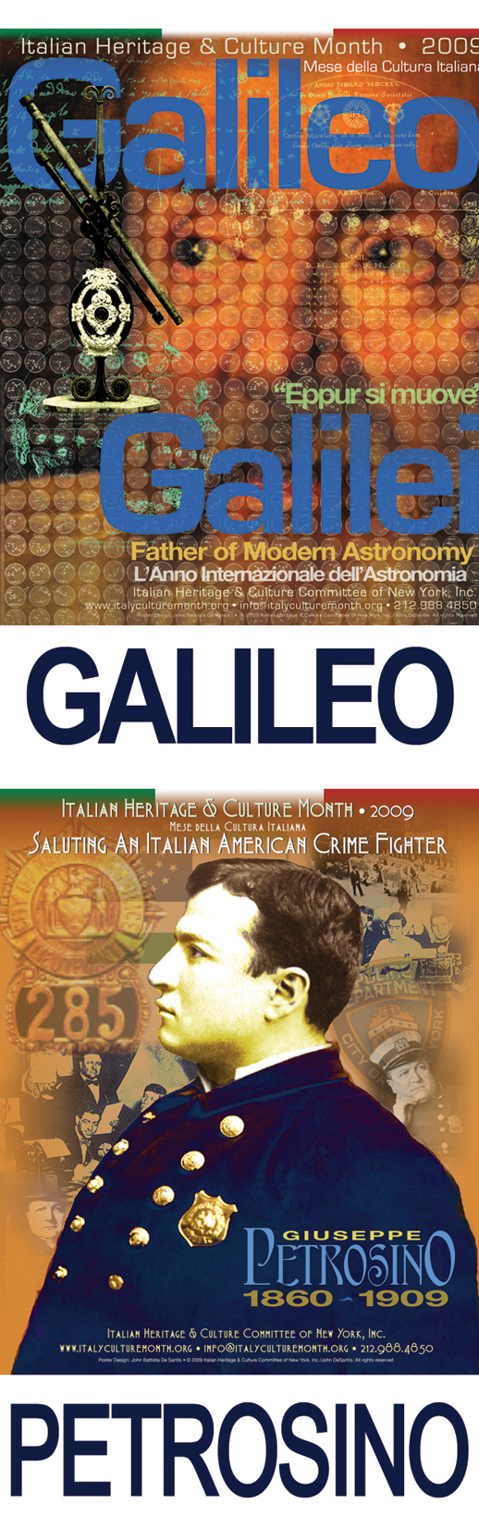

686 Park Avenue New York, N.Y. 10021 • Tel 212.988.4850 • Fax: 212.861.4018
www.italyculturemonth.org •

